ORDINANCE NO. 1407 Summary

On September 8, 2026, the governing body of the City of Girard, Kansas, adopted Ordinance No. 1407, entitled: FLOODPLAIN MANAGEMENT ORDINANCE. The purpose of this ordinance is to update local regulations governing floodplain provisions provided by the National Flood Insurance Program (NFIP). It is administered in compliance with the Federal Emergency Management Agency (FEMA) and the Division of Water Resources of the Kansas Department of Agriculture.

The regulations apply to all lands in the City that are located within the designated Special Flood Hazard Areas on the official Flood Insurance Rate Maps (FIRMs). The ordinance establishes restrictions on development, requires floodplain development permits, and outlines structural standards to minimize flood damage within the City of Girard, Kansas.
A complete copy of this ordinance may be obtained or viewed free of charge at www.girardkansas.gov or at the office of the City Clerk, City Hall, 120 N Ozark St, Girard, KS 66743. A reproduction of the original ordinance is available for a minimum of one week following the summary publication in the newspaper.
CITY ATTORNEY'S CERTIFICATION
I, the undersigned City Attorney for the City of Girard, Kansas, hereby certify that the foregoing Summary of Ordinance No. 1407 is legally accurate and sufficient pursuant to K.S.A. 12-3007.

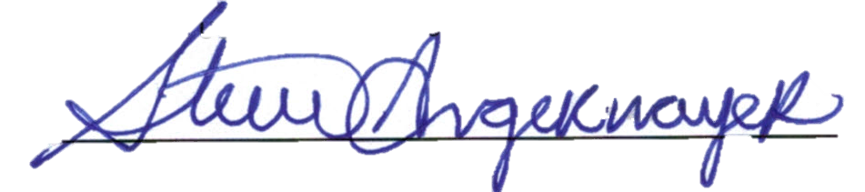

Stephen B. Angermayer,
City Attorney

